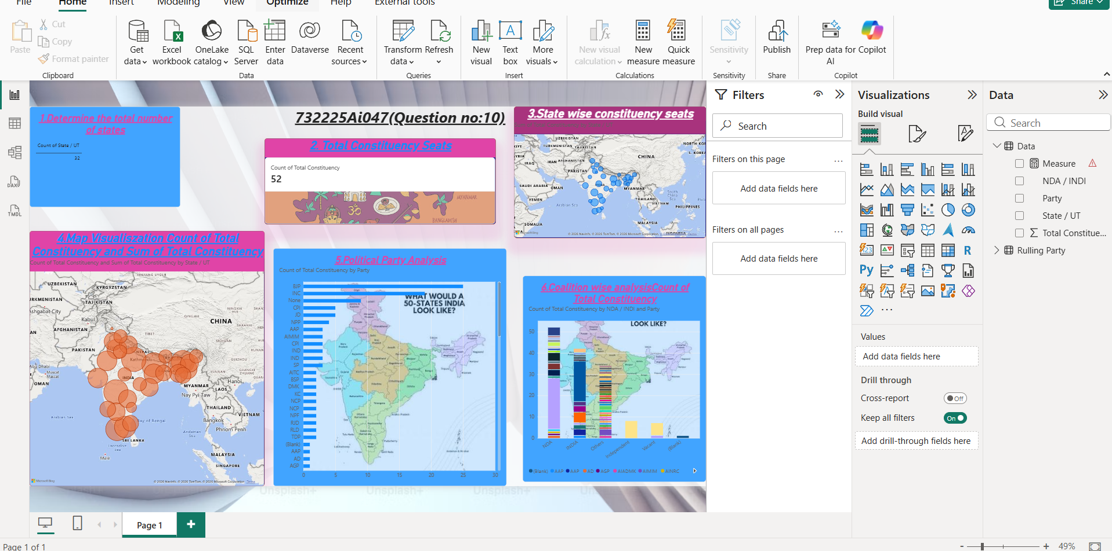
Question no:10 (732225Ai047)

